**Sprint 1 - Endurance Design Document**

**Sprint 1 - Endurance m Document**

**October XX, 2019**

***This document contains instructions and examples which are for the benefit of the person writing the document. All text in RED should be removed and replaced with information pertinent to your project*.**

**Text in the finalized document must be BLACK.**

**This is the System Design Document (SDD) and will include sections detailing system flow, algorithms, staffing plan, software/hardware, and Test Plan**

**You must complete all sections of this document.**

**Where required by the Sprint Checklist you must embed images of some artifacts in this SDD**

**To regenerate the TOC in Word, select all (CTL-A) and press F9.**

**Table of Contents**

1. **Executive Summary 3**
   1. **Project Overview 3**
   2. **Purpose and Scope of this Specification 3**
2. **Product/Service Description 3**
   1. **Product Context 3**
   2. **User Characteristics 3**
3. **Assumptions 3**
4. **Constraints 3**
5. **Dependencies 4**
6. **Requirements 4**
7. **Functional Requirements 4**
8. **Security 5**
   1. ***Protection 5***
   2. ***Authorization and Authentication 5***
9. **Portability 5**
10. **Requirements Confirmation/Stakeholder sign-off 5**
11. **System Design 5**
    1. **Algorithm 6**
12. **System Flow 6**
13. **Software 6**
14. **Hardware 6**
15. **Test Plan 6**
16. **Task List/Gantt Chart 6**
17. **Staffing Plan 6**

**1. Executive Summary**

***1.1 Project Overview***

**Describe this project or product and its intended audience, or provide a link or reference to the project charter.**

**The idea of this project is to use our coding and software engineering skills to control a robot, and make the robot follow the steps that were provided. This is intended to reach the audience of the rest of our class and professor Eckert.**

**1.2 Purpose and Scope of this Specification**

**Describe the purpose of this specification and its intended audience. Include a description of what is within the scope what is outside of the scope of these specifications. For example:**

**In scope**

The purpose of this project is to have our robot complete a run around our classroom with very specific instructions on where to go and when to go there. It will be presenting its endurance to professor Eckert. All of the instructions for the robot to complete the activity correctly will be listed within the scope

**Product/Service Description**

The general factors that affect the product and its requirements are the code that we write and any outside factors such as objects on the floor. Also the robot itself if it is damaged or broken it may not be used correctly. All of these factors are the reasons why we have these specific requirements.

1. ***Product Context***

We are using the Sphero coding system in order to control our robot and make it follow the specific instructions it gives.

**How does this product relate to other products? Is it independent and self-contained? Does it interface with a variety of related systems? Describe these relationships or use a diagram to show the major components of the larger system, interconnections, and external interfaces.**

1. ***User Characteristics***

**There will be three of us working on the project. We are all new to coding and have never used the Sphero system before. Hopefully we can learn the best way to use Sphero by doing the project and learn as we go along.**

**List any assumptions that affect the requirements, for example, equipment availability, user expertise, etc. For example, a specific operating system is assumed to be available; if the operating system is not available, the Requirements Specification would then have to change accordingly.**

1. ***Assumptions***

* **Having wrong numbers and wrong code blocks**
* **Not having access to the room**
* **Objects in the way**
* **Damaged equipment**
* **Sphero out of battery**

1. ***Constraints***

* **Room availability**
* **Due date**
* **Resources**

**List dependencies that affect the requirements. Examples:**

**Dependencies**

* **Code must be written in block**
* **Code must be completed for the robot to run**
* **Room must be available**
* **Robot must be charged**

**Requirements**

**Endurance**

**1. There will be a piece of tape on the floor of the classroom that the robot must follow**

**2. We will begin by placing the robot at the starting point**

**3.Once placed on the starting point the robot must say “Ready Set Go”**

**4. The robot will then go straight a distance of 160’**

**5. Delay for a second and roll 90 degrees a distance of 100’**

**6. Delay for a second then go 180 degrees for a distance of 60’**

**7. Dealy a second , change to color**

**8.Speak “Im done i need some water”**

1. ***Functional Requirements***

| **Req#** | **Requirement** | **Comments** | **Priority** | **Date Rvwd** | **SME Reviewed / Approved** |
| --- | --- | --- | --- | --- | --- |
| **ENDUR_01** | **There will be a rectangular shaped course in the classroom that the robot must follow, based on our code.** | **The robot is sometimes affected by the blue tape because it is ripped and peeking off the floor.** |  | **10/29/23** | **Approved** |
| **ENDUR_02** | **The robot will begin by glowing green and saying “Ready set go” Then begins to move across the room** | **Met requirement** |  | **10/29/23** | **Approged** |
| **ENDUR_03** | **Robot goes forward for a distance 9.4 seconds at 100 speed** | **Meets requirements** |  | **10/30/23** | **approved** |
| **ENDUR_5** | **The robot continues to follow the code and goes at a speed of 100’ at an angle of 90 degrees for 5.2 seconds** | **Meets requirements** |  | **10/30/23** | **approved** |
| **ENDUR_6** | **Makes a turn at the angle of 180 degrees and continues another at the speed of 10 for 9.4** | **Meets requirements** |  | **11/3/23** | **approved** |
| **ENDUR_7** | **Travels at 100’ once again but this time at an angle of 270 for 5.2 seconds** | **Meets requirements** |  | **11/3** | **approved** |
| **ENDUR_8** | **The robot reaches the endpoint and says “Im done i need water”** | **Meets requirements** |  | **11/3/23** | **approved** |
| **ENDUR_9** | **Robot arrives at the starting point** | **Meets requirements** |  | **11/3** | **approved** |
| **ENDUR_10** | **The robots cannot collide with any objects** | **Meets requirements** |  | **11/3** | **approved** |
| **ENDUR_XX** |  |  |  |  |  |

1. ***Security***

**3.3 Protection**

**There is one person who is in sole possession of the robot. They are not allowed to give it to any other group members to prevent losing it or miscommunications. The person who possess the robot signed off on it to ensure they do not lose it and are in full responsibility**

**3.3 Authorization and Authentication**

**In order to access the Sphero app you must have a device that is compatible and you must have an account.**

***3.4 Portability***

**Include documentation of the approval or confirmation of the requirements here. For example:**

| **Meeting Date** | **Attendees (name and role)** | **Comments** |
| --- | --- | --- |
| **10/30/23** | Salvatore, David, Deuce | **confirmed all except ENDUR_XX** |
| **11/3/23** | Salvatore , David, Deuce | **Confirmed** |

1. **System Design**
2. ***Algorithm***

* **Place the robot on the starting point**
* **Robot turns on green light, starts and say “ready set go”**
* **Robot runs a speed of 100 for 9.4 seconds**
* **Robot turns at an angle of 90 degrees and goes the speed 100 for 5.2 seconds**
* **Robot turns at an angle of 180 degrees and goes the speed 9.4’**
* **Robot turns at an angle of 270 degrees and goes the speed 100 for 5.2 seconds**
* **Robot reaches end point**
* **Robot turns red and says “I'm done now I need water”**

***System Flow***

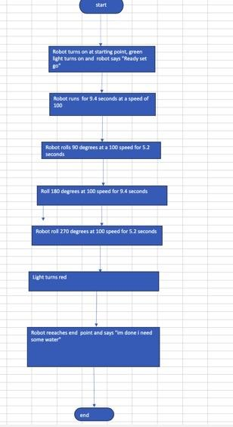

***Software***

**Describe software languages/platforms/api’s used to develop and deploy this application. Embed your block code here**

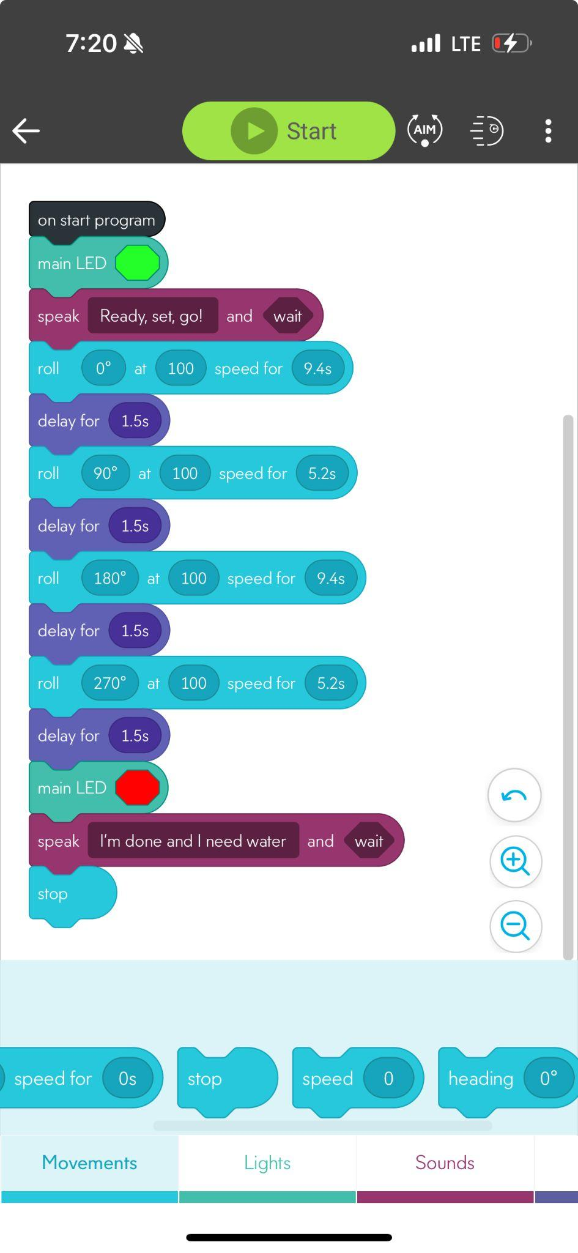

1. ***Hardware***

**Laptops and phones were used**

1. ***Test Plan***

**Include a test plan showing all unit tests performed for this application, Include test rational, test date, staff member, pass/fail status**

| **Reason for Test Case** | **Test Date** | **Expected Output** | **Observed Output** | **Staff Name** | **Pass/Fail** |
| --- | --- | --- | --- | --- | --- |
| **To get data for the project** | **10/30/23** | **To follow line** | **Did not follow the line** | **Sal david** | **fail** |
| **Test 150 speed** | **10/30** | **To have an appropriate speed to conduct the experiment** | **Was to fast had to slow it down** | **Deuce david sal** | **fail** |
| **Test 120 speed** | **10/30** | **To have an appropriate speed to conduct the experiment** | **Was to fast had to slow it down** | **Deuce david sal** | **fail** |
| **Test 120 speed** | **10/30** | **To have an appropriate speed to conduct the experiment** | **Perfect speed** | **Deuce david sal** | **pass** |
| **Test 9.4 seconds for first path** | **10/30** | **To have a fitting time to follow the lime** | **Worked well** | **Deuce david sal** | **pass** |
| **Test 5.2** | **10/30** | **To have a fitting time to follow the lime** | **Worked well** | **Deuce david sal** | **pass** |
|  |  |  |  |  |  |
|  |  |  |  |  |  |
|  |  |  |  |  |  |
|  |  |  |  |  |  |
|  |  |  |  |  |  |

1. ***Task List/Gantt Chart***

**\**

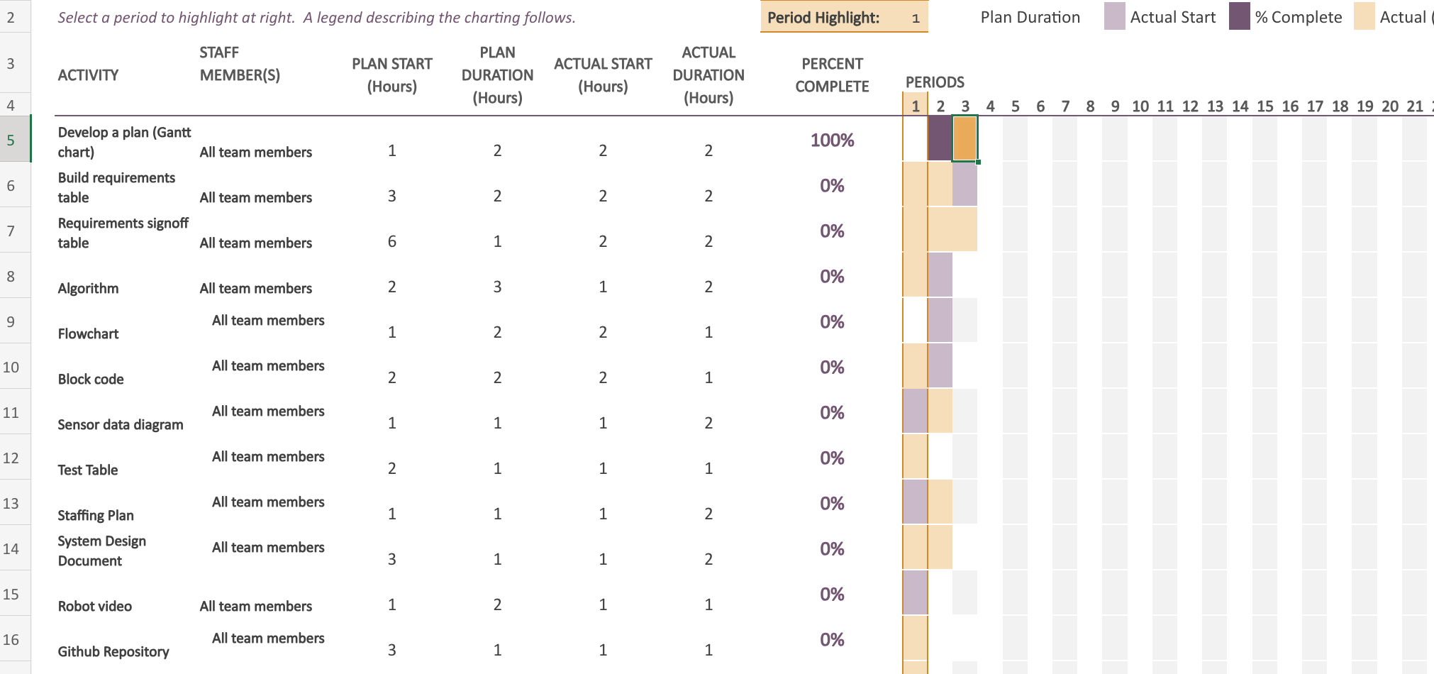

***Staffing Plan***

**Insert a chart/table that depicts the roles and responsibilities of each team member that worked on this project**

| **Name** | **Role** | **Responsibility** | **Reports To** |
| --- | --- | --- | --- |
| **sal** | **Logged all information into the charts and the document** | **Diligently checked the numbers on the code and the moved them to document** | **David** |
| **David** | **Trial and error process of the robot** | **Wrote the code and made observations** | **Sal** |
| **Deuce** |  |  |  |